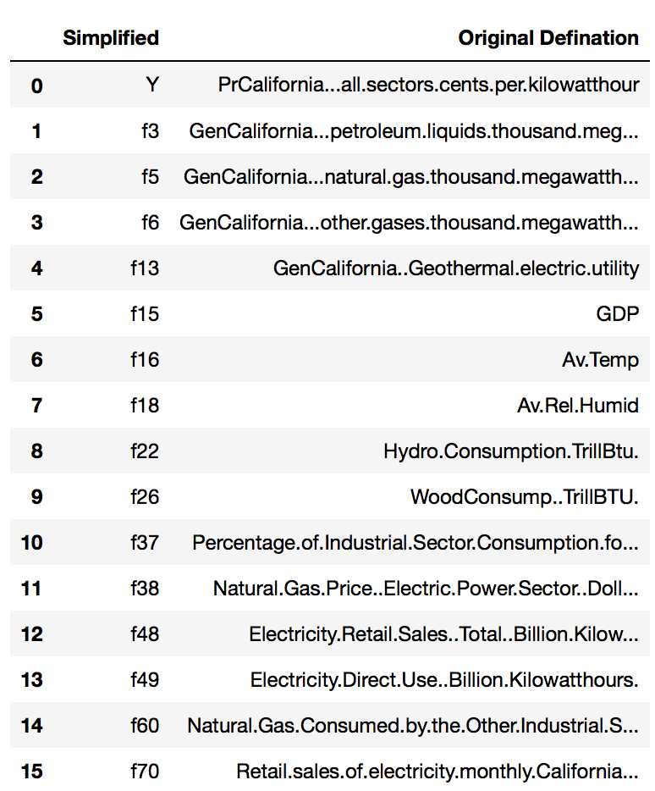

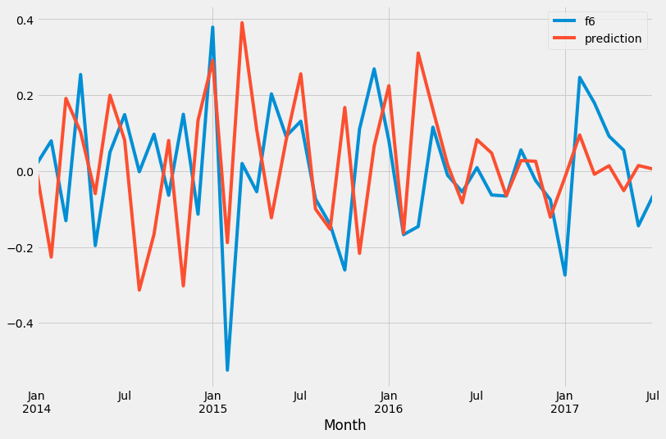

order=(1, 1, 1), seasonal_order=(1,0,2,12),

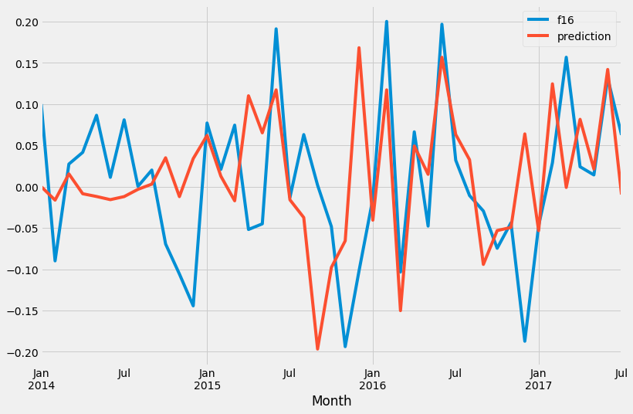

order=(1, 0, 2), seasonal_order=(1,1,1,12),

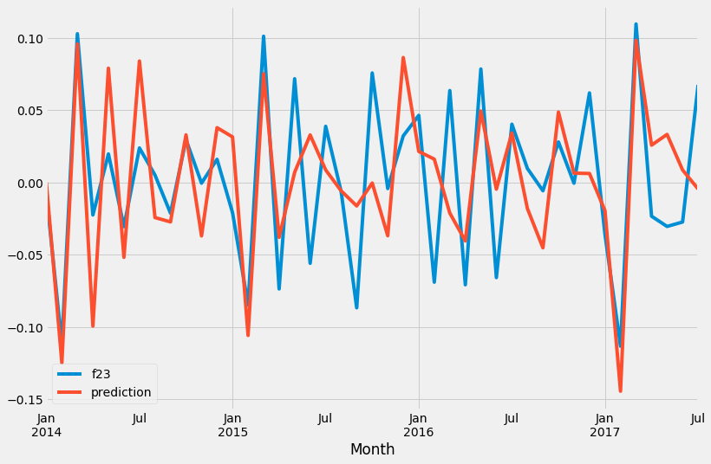

order=(0, 1, 0), seasonal_order=(0,0,1,12)

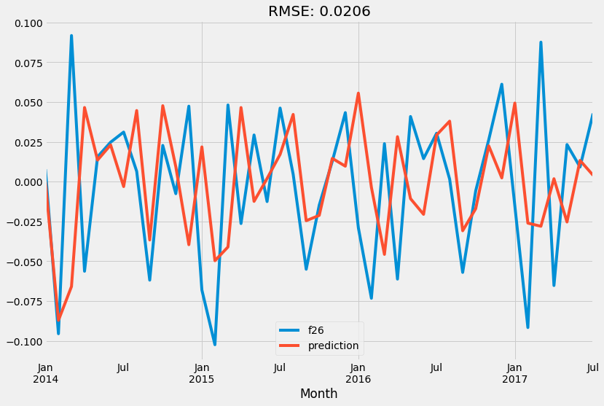

order=(1, 1, 0), seasonal_order=(0,0,0,12)

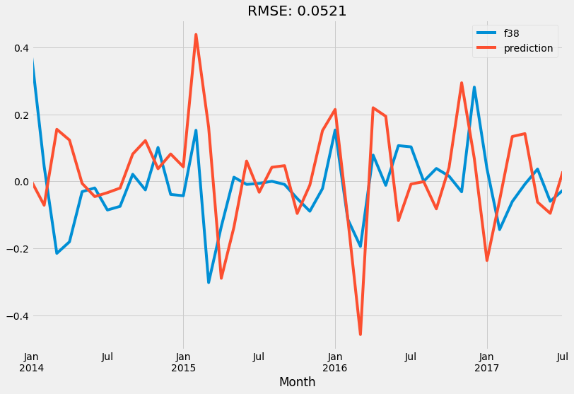

order=(1, 1, 0), seasonal_order=(0,1,0,12)

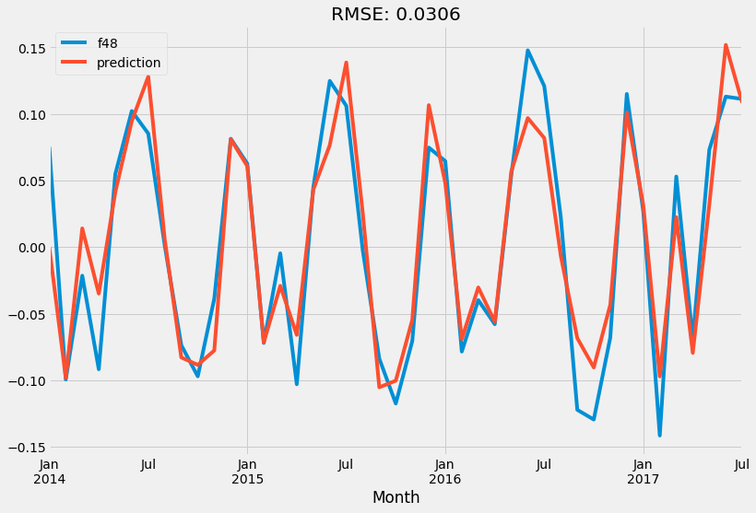

order=(0, 1, 1), seasonal_order=(0,0,0,12)

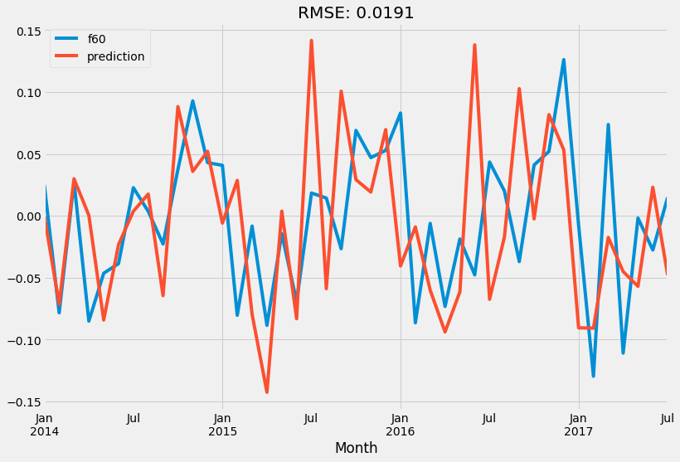

order=(0, 1, 0), seasonal_order=(1,1,0,12)

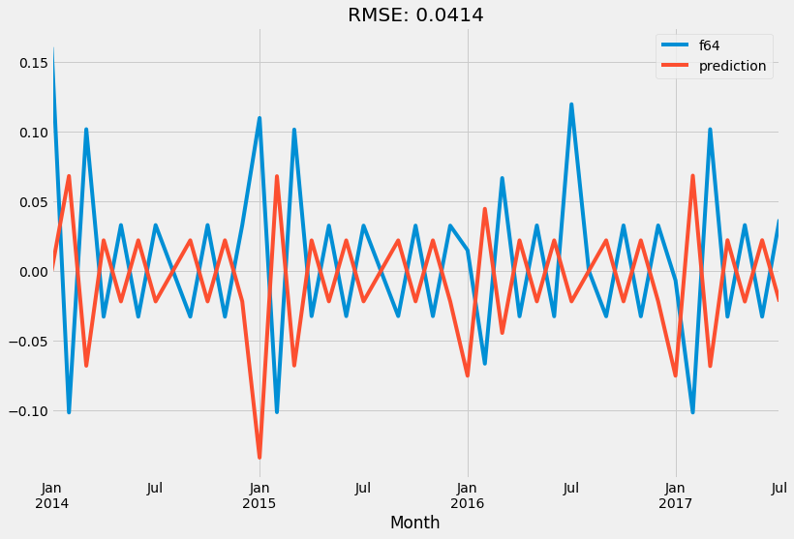

order=(1, 0, 0), seasonal_order=(0,0,0,12)